**SUPREME SHUTTLE FLEET MANAGEMENT SYSTEM**

**BRIEF OVERVIEW**

## SYSTEM OBJECTIVES

### Main objective

A fleet management system that helps the admin to increase efficiency in managing vehicles, drivers, fuel, revenue, issues (accidents), uploads and hired vehicles.

### Minor objectives

1. A fleet management system that enables admin to register, update, view and delete vehicles (CRUD operations of the database).
2. A fleet management system that enables admin to register, update, view and delete drivers (CRUD operations of the database).
3. A fleet management system that enables admin to calculate profits or losses made by the vehicles in a specified period.
4. A fleet management system that enables admin to appraise drivers based on criteria such as integrity, discipline, punctuality, and decency and award them average points on a scale 0f 1 to 5 and give comments accordingly.
5. A fleet management system that enables admin to calculate net pay of drivers.
6. To develop a fleet management system that will help admin to calculate the amount of fuel consumed by vehicles at a specific time range.
7. To develop a fleet management system that will help admin to view vehicles hired by clients (customers).
8. A fleet management system that enables admin to upload files which can then be downloaded by drivers.
9. A fleet management system that enables admin to register issues such as accidents and traffic irregularities.
10. A fleet management system that enables admin to have a high-level view of various operations conducted by the system such as viewing total number of drivers, vehicles, etc.
11. A fleet management system that enables drivers to view their appraisal report.
12. To develop a fleet management system that will enable driver to download files uploaded by the admin.
13. A fleet management system that enables drivers to view various notices posted on their portal.
14. A fleet management system that enables drivers to send message to admin.
15. A fleet management system that enables customers to view about the Supreme Shuttle company.
16. A fleet management system that enables customers to hire a vehicle in the Supreme Shuttle company.
17. A fleet management system that enables customers to view contacts of the Supreme Shuttle company.

# SYSTEM DEVELOPMENT TOOLS AND TECHNIQUES

1. **Programming Languages**

* Front end: HTML, CSS, and JavaScript.
* Back end: PHP.

1. **Database Tools**

* MySQL.

1. **Graphics Tools**

* Adobe Photoshop.
* Adobe Illustrator.

1. **Server**

* XAMPP server.

1. **Operating System**

* Windows 10.

**SYSTEM ANALYSIS AND REQUIREMENT MODELING**

## Data Flow Diagrams

The figure below is the zero level DFD which shows the high-level entities ad process flow of the Supreme Shuttle Fleet Management System which include managing all vehicles, managing all drivers, managing revenue, managing fuel, and managing issues.

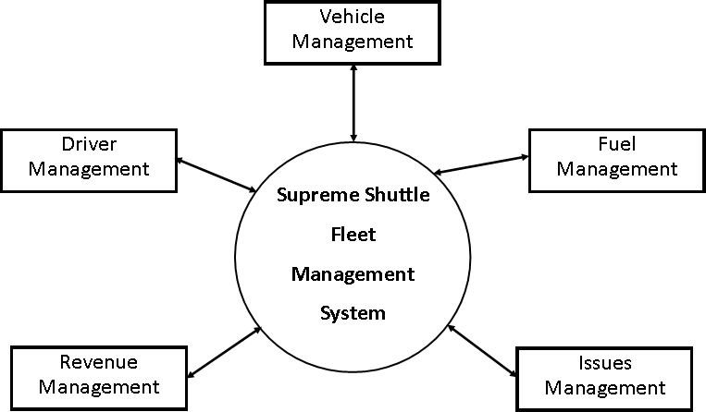

Figure 1: Zero Level DFD

The figure below is a first level DFD

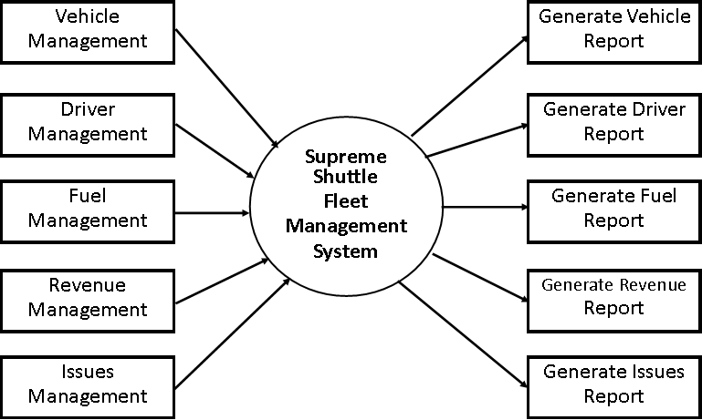

Figure 2: First Level DFD

The major entities and output of first level DFD include:

1. Processing of driver records and generating their reports.
2. Processing of vehicle records and generating their reports.
3. Processing of fuel records and generating their reports.
4. Processing of issues records and generating their reports.

The figure below is a second level DFD contains the low-level functionalities of the system including the ability of the admin to:

1. Login into the system and manage all the functionalities of the system.
2. Perform CRUD operations on records i.e., create (insert), read (view), update (edit), and delete records.
3. Manage all details of drivers, vehicles, fuel, revenue, and issues.
4. Search details of vehicles and drivers.

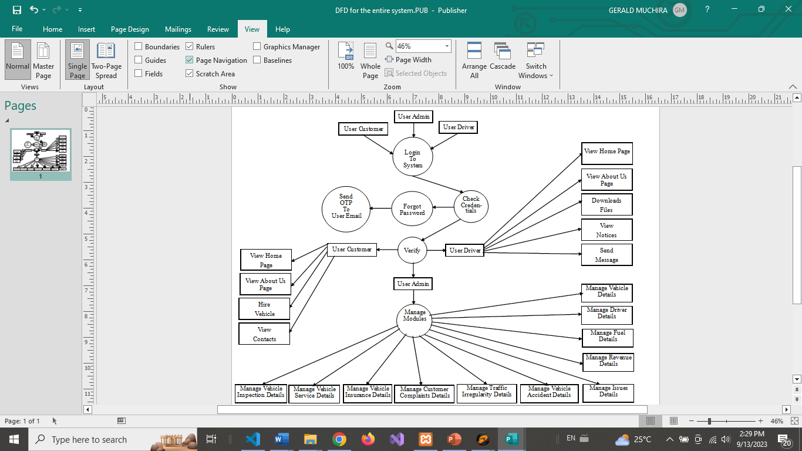

*Figure 3: Second Level DFD*

## Use Case Diagrams

The below figure depicts the use case diagram for the Supreme Shuttle Fleet Management System project. It shows the two types of actors and all the different use cases using which the actors interact with the system.

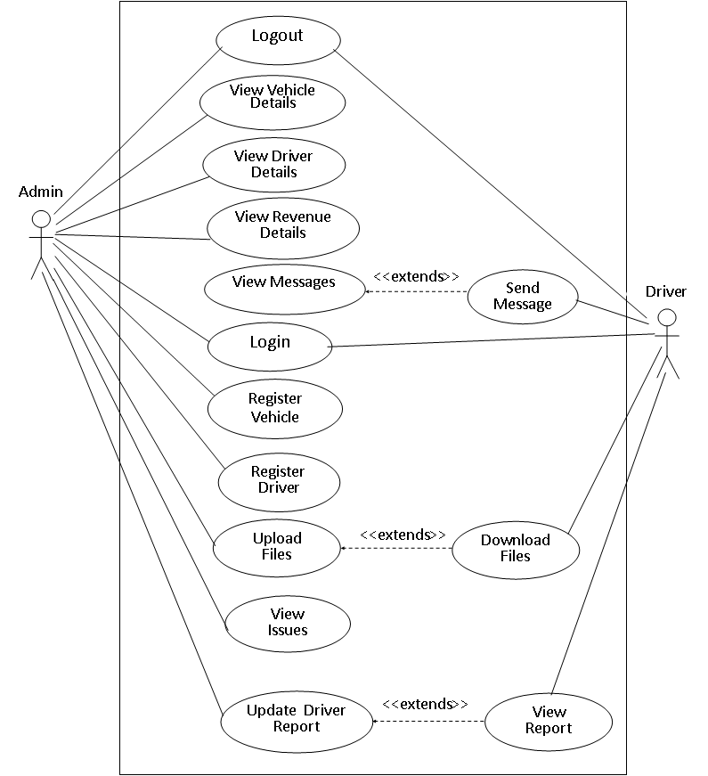

*Figure 4: Integrated Use Case Diagram for Admin and Driver*

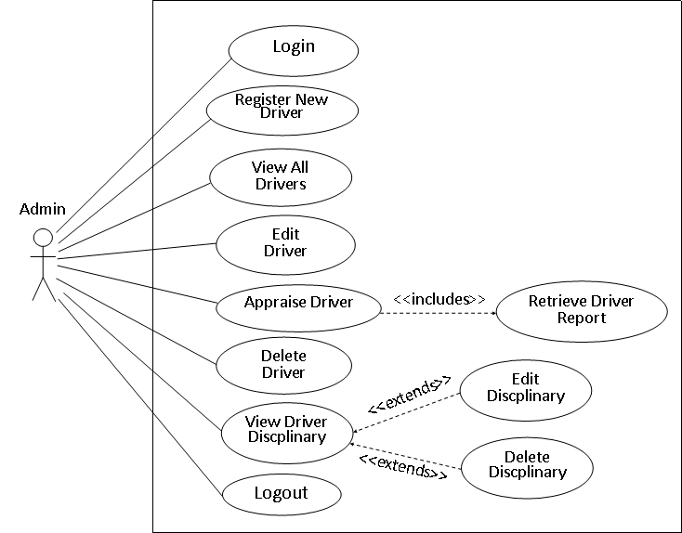

*Figure 5: Use Case for Driver Registration*

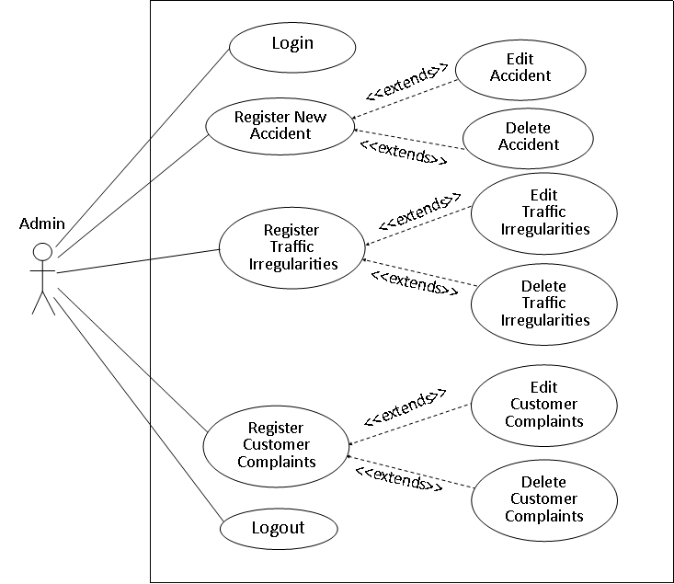

*Figure 6: Use Case on Issues Management*

## 

## Class Diagram

The following class diagram shows the static structure of Supreme Shuttle Fleet Management System.

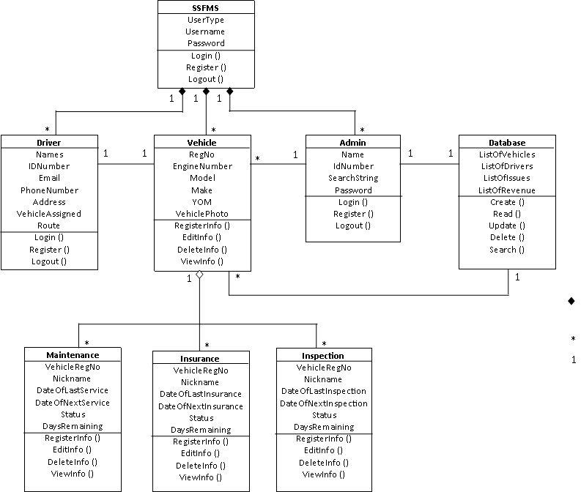

*Figure 7: Class Diagram for Supreme Shuttle Fleet Management System*

## Object Diagram

In the Supreme Shuttle Fleet Management System, there are various objects which have been used and they interact with each through message passing. Some of the objects which have been used in the Supreme Shuttle Fleet Management System include vehicles, drivers, issues, revenue, and fuel. The following object diagrams shows the relationship between the various objects in the system.

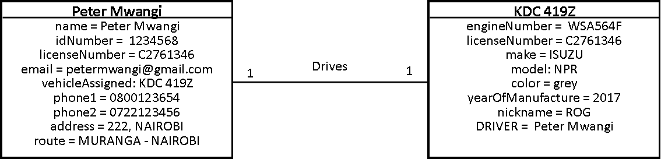

*Figure 8: Object Diagram to show Relationship between Driver and Vehicle*

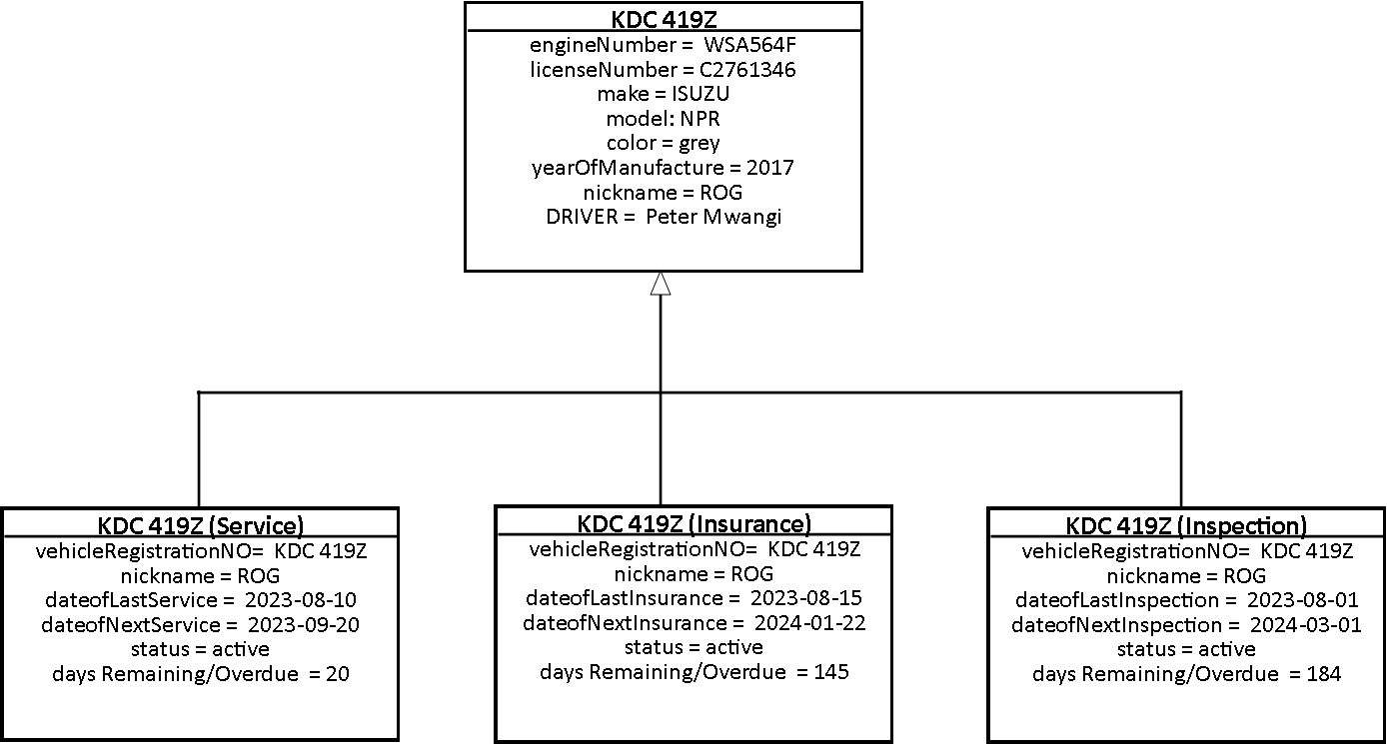

*Figure 9: Object Diagram to Show Vehicle Maintenance*